Address for User Panel’s Buttons and Indicators

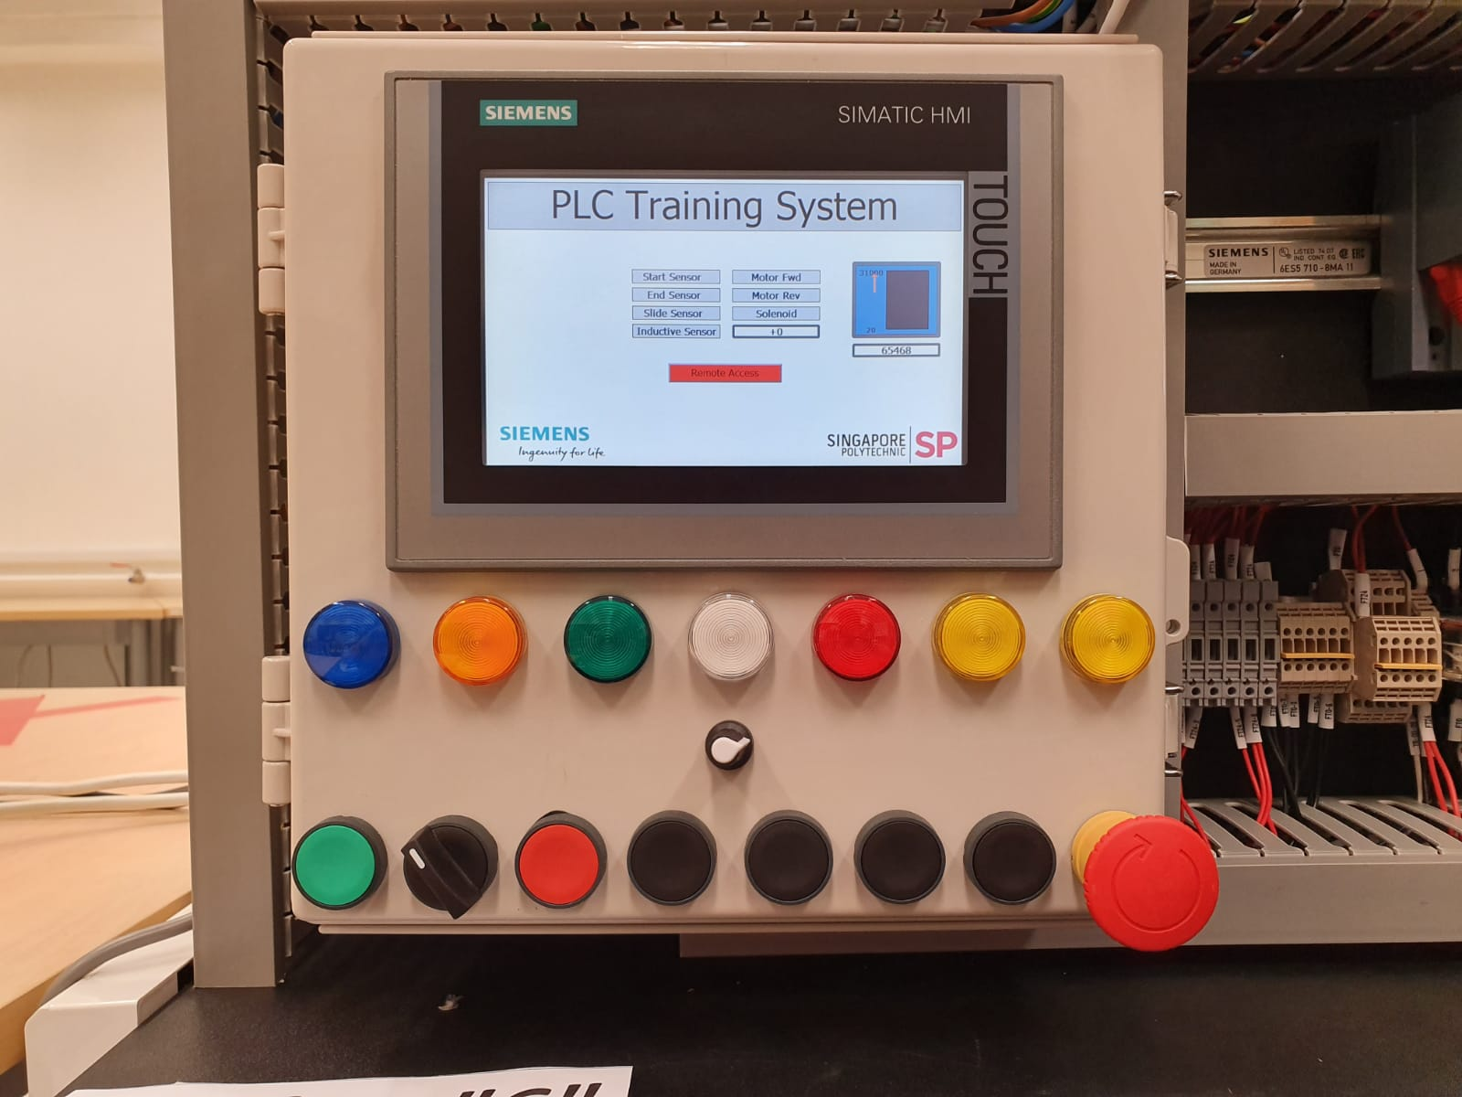

PB1 Selector PB2 PB3 PB4 PB5 PB6 ESTOP  
%I126.7 .6 .5 .4 .3 .2 .1 .0

Potentiometer %IW128

%Q128.6 .5 .4 .3 .2 .1 .0  
 LED1 LED2 LED3 LED4 LED5 LED6 LED7

IP address and Profinet Device Names

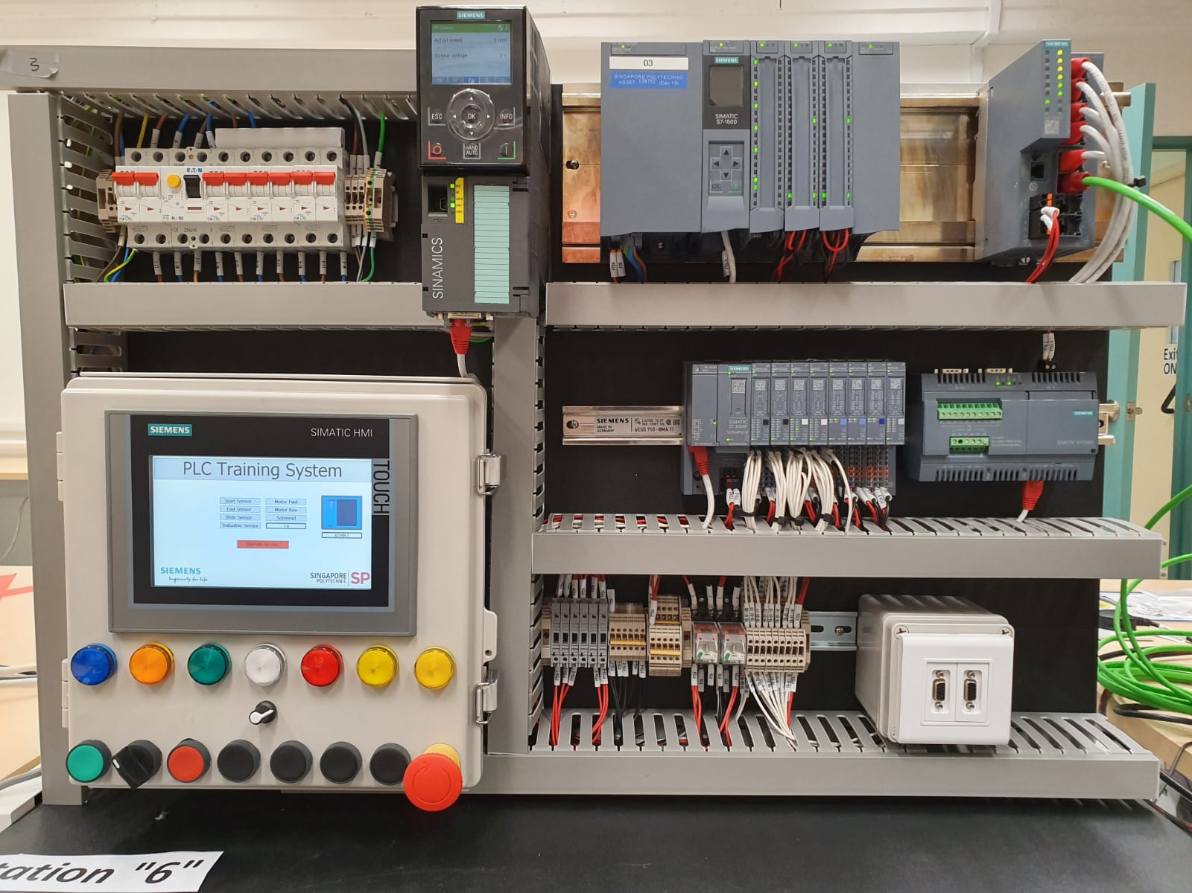

Drive_2  
192.168.0.7

Switch_1  
192.168.0.2

PLC_1  
192.168.0.1

IO device_1 **192.168.0.4**

HMI_1  
192.168.0.5

Address for Conveyor System

Sensor_Inductive  
%I127.3

**Motor_FWD %Q129.0  
Motor_REV %Q129.1**

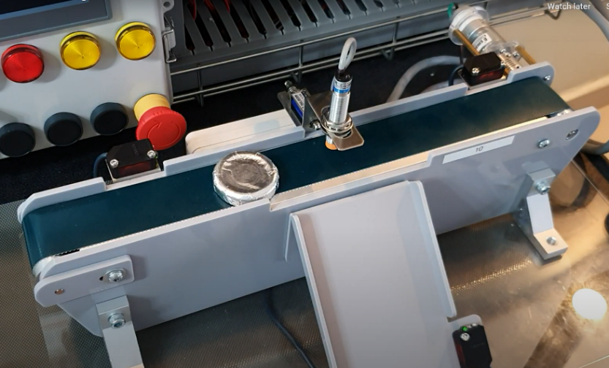

**Solenoid  
%Q129.2**

Sensor_Start  
%I127.1

Sensor_Slide  
%I127.0

Sensor_End  
%I127.2